The goals of the game flow are:
- The gameplay is linear and sequential.
- Each objective is discreet and self-contained – that is, not dependent on actions taken in other objectives.
- Account for three game states – sequential completion of objectives in a game session, mission failure restarts, and loading a saved game in which some objectives are already complete.

The objectives a player can be asked to do are:
- GO TO a location (locator) by vehicle or on foot
- TALK TO a character (a special case of GO TO)
- GET INTO a specific vehicle (a special case of GO TO)
- COLLECT item(s)
- COLLECT AND DELIVER item(s) TO destination (locator)
  - Note that an “item” can be person, object, or animal – specific vehicles can carry specific items, with a vehicle-specific maximum load
- FOLLOW AI vehicle TO destination (locator)
- DESTROY AI vehicle(s)
- DESTROY object(s)

Failure conditions for an objective can be:
- PLAYER VEHICLE DESTROYED
- TIME EXPIRED
- PLAYER DETECTED (on-foot only)
- PLAYER TOUCHED (on-foot only)
- PLAYER GETS OUT OF VEHICLE???

Other attributes of an objective:
- Set or reference start conditions for a mission (e.g., on foot there might be a start position and walking path for an NPC character; in-car there might be a corresponding location for a chase/escape vehicle)
- Presentation/HUD interface (e.g., refer to camera work/NIS data, HUD text, etc.)
- AI settings:
  - Set aggression/density of chase vehicle(s) globally for the objective; car model of chase vehicles
  - Set the aggression/density of the chase AI relative to how many objects you are carrying, e.g.:
    - AI LEVEL 1 IF CARRYING 1
    - AI LEVEL 1 IF CARRYING 2
    - AI LEVEL 2 IF CARRYING 3
- TIMER (implies a fail condition if it expires)
- START LOCATION (a locator/trigger that kicks off gameplay)
- VEHICLE REQUIREMENT
- DELIVERY LOCATION

The objectives are played out in a linear fashion as shown in Figure 1 (on the following page).

Some rules that are implied by this system:
- An objective can require a particular car, and have a triggered start location
  - These are “implied objectives”. They appear as objectives to the user, but are scripted as part of an objective’s attributes. This handles all possible out-of-car scenarios consistently. For example, if you are being pointed towards a start trigger and you get out of the car (or if you load a saved game) the game will direct you to get back into the specific car.
  - Once the user is in the necessary car, they are directed to go to the start locator/trigger.
- Save Points are logical, in-memory save points – this is where the user respawns to when an objective fails. The user has to explicitly save via the memory card (or when prompted when they quit the game). When they restore a saved game, it resumes at a save point.
- After mission-failure presentation, the game resets the player to the most recent save point
- After a save point, the next objective will always require a specific vehicle – so that when a game is loaded from the memory card, there is a consistent way of setting up and accessing the next mission.
- The user always plays as one character throughout a game level. They can get into their own car as driver, or certain other cars as a passenger. They have one start location (in or near their own car) where they always start when that level is loaded, whether for a new game or saved game.

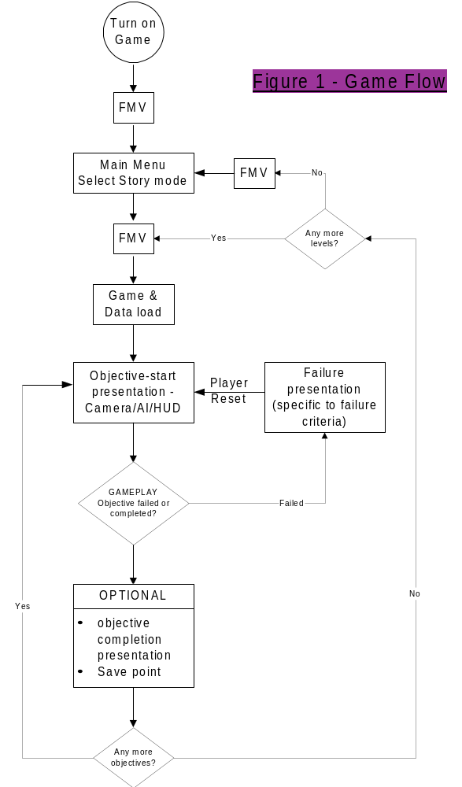

Example Pseudo-script
This is an example script for a sequence of objectives. The user character is Bart, and they start the game on-foot near the stadium and Homer Simpson (who is in his pink car). The objectives are:
- get into Homer’s car and escape the Truckasaurus
- go into the Android’s Dungeon and steal a comic book
- talk to Moe about Panda bears (you find out you need a truck)
- Go to Cletus, and get into his truck, then return to Moes and talk to him again
- Collect 5 panda bears within a time limit

objective GO_TO androids_dungeon // a locator inside the store
// escape from the Truckasaurus into the Android’s Dungeon
{
name escape_Truckasaurus_1 // a name may be needed to
// interface to sound tools
vehicle_required Homer_sedan
start_location Truckasaurus_1 // a Maya locator/trigger
failure_user_disabled nis_user_destroyed
// fail mission if destroyed

chase_AI_level 1 // set AI aggression
chase_vehicle Truckasaurus
chase_start_location Truckasaurus_2 // Chase start location
HUD_text “Escape the Truckasaurus!” // in a real script this would
// refer to the text-bible
save_point // save if successful
success_nis see_Truckasaurus // watch him run by
}

objective COLLECT radioactive_man_72
// collect an object that’s been placed in Maya
// steal Radioactive Man comic
{
name steal_radioactive_man
start_location androids_dungeon // star the timer when the user
// is in this trigger
nis_pre_start show_comic book // play a presentation NIS before
// starting the timer
failure_user_detected nis_CBG_detected
// fail if AI character sees you

timer 30 // fail if timer expires
NPC comic_book_guy androids_dungeon_path_1
// starting location/path for NPC
// from Maya data

}

objective GET_INTO Homer_sedan
// get back into the car
{
name get_into_Homer_sedan
failure_user_touched nis_CBG_caught
save_point // save if successful
}

objective TALK_TO Moe
// talk to a character who’d been placed in Maya
// he’ll tell you that you need a truck
{
name talk_to_Moe_pre_panda
// no fail or gameplay critieria
// will need dialog interface – system TDB
}

objective GO_TO Moes_locator
// you may already be at Moes – but you need to get Cletus truck as
// part of the vehicle requirement
{
name get_cletus_truck_pandas
vehicle_required Cletus_truck // you will be directed to Cletus truck
// before you are sent to Moes
}

objective TALK_TO Moe
{
name talk_to_Moe_panda // here about mission objectives
}

objective COLLECT_DELIVER Pandas 5
// deliver 5 panda bears
{
name deliver_pandas_1
vehicle_required Cletus_truck
start_location Panda_1 // a Maya locator/trigger
delivery_location behind_moes // another locator/trigger
timer 120 // two minutes to do the mission
chase_AI_levels // set AI aggression per object load
{
AI LEVEL 1 IF CARRYING 1
AI LEVEL 1 IF CARRYING 2
AI LEVEL 2 IF CARRYING 3
}
// no NIS presentation defined, as the only failure condition is the
// timer expiring – there would be a generic NIS for this event, since
// it can happen in any conditions
}

